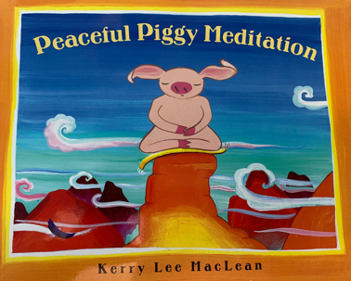

After listening to Peaceful Piggy Meditation, students from grade 2/3 used loose parts to share their stories of what makes them feel calm.

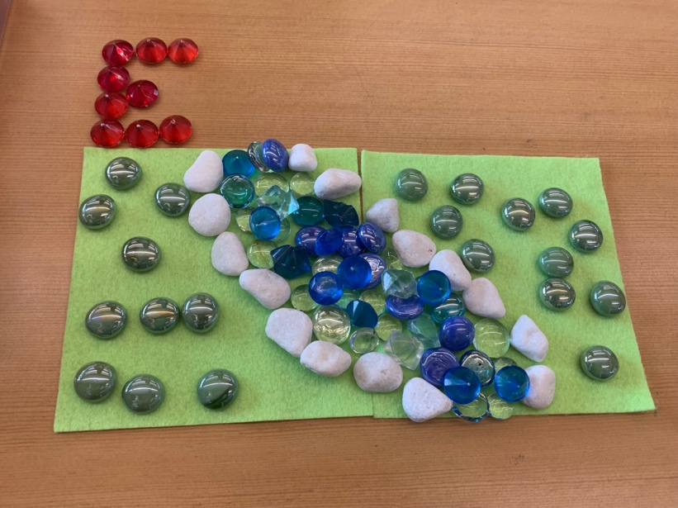

Student 1: “Listening to the water flow in the river makes me feel calm.”

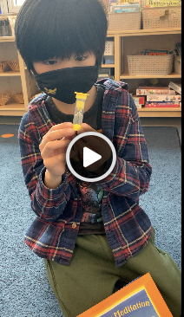

Student 2: “I like to look at a timer to be calm. I know how much time I have left on an activity.”

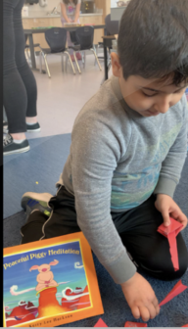

Student 3: “I like to make paper creations. Working with my hands helps me feel calm.”

