Cook Community
The Week Ahead: October 23 – 27, 2023

Monday | Breakfast Club
Tuesday | Breakfast Club
Wednesday | Breakfast Club  Gr. 6/7 Volleyball Game at Anderson
Thursday | Breakfast Club  Individual Photos
Friday | Breakfast Club

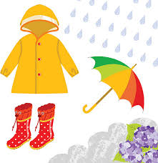
Important Information:

- The wet weather is upon us. Please be sure to send your child to school with appropriate clothing.
- On Thursday, October 26, Edge Photography will be coming to take individual photos of your child. If your child is away absent, we have retakes on November 14th.
- WE NEED YOU! We are so excited for our Book Fair to come to Cook Library on November 21 – 24th. We really need parent support to help make this a successful fundraiser. If you are available, any of these days from 8:15am til 8:45am OR 2:45pm to 3:30pm, please email Ms. Storey at tstorey@sd38.bc.ca

- Halloween “Trick or Treating” with respect...
Halloween is a time for fun; however, we need to be aware that celebrating Halloween needs to be fun for ALL. Halloween offers an opportunity to have meaningful conversations about costume choices and requires consideration. In doing so, it is important to keep in mind that we need to be sensitive to groups that have been marginalized through imitating someone and cultural appropriation during Halloween and other ‘dress up’ events. It’s good to keep in mind that the following are NOT appropriate costumes...
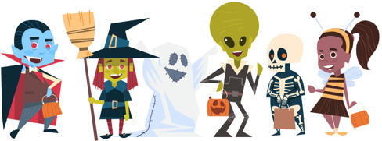
  - Race (black face/brown face)
  - Culture (Indigenous regalia/dreadlocks)
  - Religious Faith (religious figures/gods/saints/gurus/hijab)
  - Gender (gender switching for humour or to mock)
  - Trauma (weapons)
DID YOU KNOW?
We are beginning a new school goal that focuses on READING! On our school website, we will add updates of our learning throughout the school year. Stay tuned as we begin this journey together. Look for our school story updates and learn alongside your children.

Upcoming Dates:
• October 26th – Individual Photo Day
• October 31st – Halloween
_____________________________________________________________________________________

~Cook Highlights~
