Cook Community
The Week Ahead: October 30 – November 3, 2023
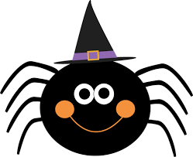
Monday | Breakfast Club
Tuesday | Breakfast Club  HALLOWEEN
Wednesday | Breakfast Club  Gr. 6/7 Volleyball Game at Cook
Thursday | Breakfast Club
Friday | Breakfast Club

Important Information:
- WE NEED YOU! We are so excited for our Book Fair to come to Cook Library on November 21 – 24th. We really need parent support to help make this a successful fundraiser. If you are available, any of these days from 8:15am til 8:45am OR 2:45pm to 3:30pm, please email Ms. Storey at tstorey@sd38.bc.ca

- Halloween “Trick or Treating” with respect...
Halloween is a time for fun; however, we need to be aware that celebrating Halloween needs to be fun for ALL. Halloween offers an opportunity to have meaningful conversations about costume choices and requires consideration. In doing so, it is important to keep in mind that we need to be sensitive to groups that have been marginalized through imitating someone and cultural appropriation during Halloween and other ‘dress up’ events. It’s good to keep in mind that the following are NOT appropriate costumes...
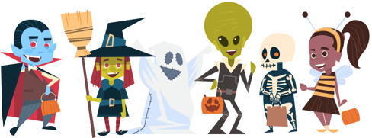
  - Race (black face/brown face)
  - Culture (Indigenous regalia/dreadlocks)
  - Religious Faith (religious figures/gods/saints/gurus/hijab)
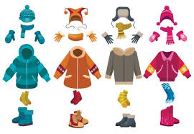
  - Gender (gender switching for humour or to mock)
  - Trauma (weapons)
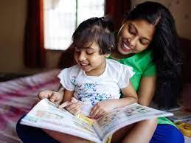
3. As the weather gets colder, please remember to send your child with a warm coat, toque, gloves and warm boots.
DID YOU KNOW?
A study completed at Ohio State University shared results showing that children who are read to in the first five years of life have a 1.4 million word advantage over children who are not read to at home.

Upcoming Dates:
• November 9 – PAC Lunch: Pizza Day
• November 10 – Remembrance Day Assemblies
• November 13 – NO SCHOOL
• November 14 – Photo Retakes
• November 20 – Professional Learning Day (NO SCHOOL)
• November 23 – PAC Lunch: Sushi
• November 29 – PAC Meeting
• December 4 – Staff Meeting at 3pm
• December 21 – Term 1 Reports sent home

_____________________________________________________________________________________

~Cook Highlights~

