Cook Community
The Week Ahead: October 9 – 13, 2023

Monday | Thanksgiving – NO SCHOOL
Tuesday | Breakfast Club
Wednesday | Breakfast Club
Thursday | Breakfast Club
Friday | Breakfast Club  Run Club celebration run at Garden City Park

Important Information:

- A friendly reminder that there is EARLY DISMISSAL on Tuesday, October 17th at 12 noon. Please be sure to pick up your child on time as all staff are in meetings for Parent-Teacher Conferences.

- The wet weather is upon us. Please be sure to send your child to school with appropriate clothing.

Upcoming Dates:
• October 9th – Thanksgiving Day (NO SCHOOL)
• October 17th – Early Dismissal at 12:00pm to support Parent-Teacher Conferences
• October 19th – PAC Lunch: Elephant’s Kitchen
• October 21st – Provincial Professional Learning Day
• October 26th – Individual Photo Day
• October 31st – Halloween

_____________________________________________________________________________________
~ Cook Highlights ~
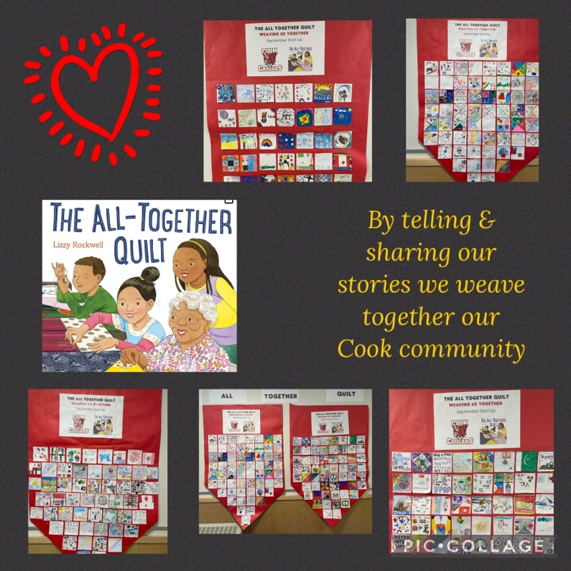

The whole school read the picture book,
The All-Together Quilt. Each student
shared a piece of their story allowing
us all to weave together what makes us
special at Cook School.

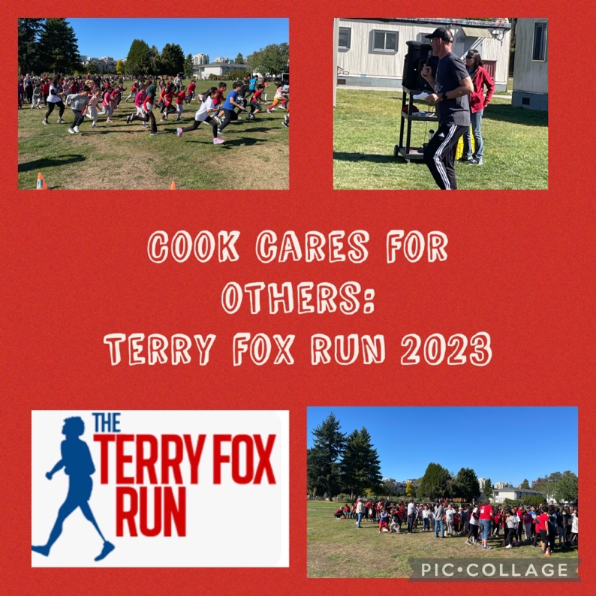

In mid September, we all took part
in remembering and honoring the
courage and bravery that Terry Fox
demonstrated in helping the world
learn and support cancer research.

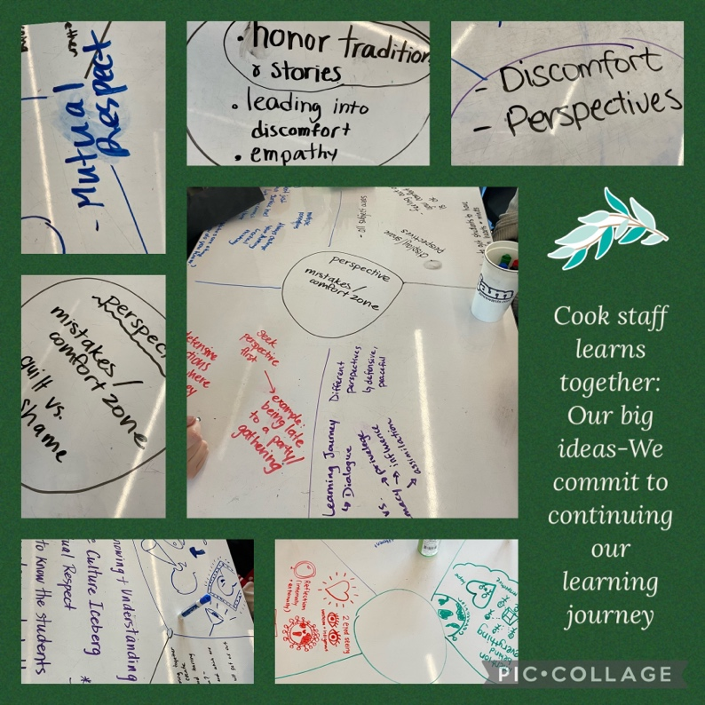

On September 22nd, all Richmond District
employees had the chance to learn and
understand the importance of First Peoples
and their place in Canada and the world.

Our staff took the time to reflect on our
learnings from listening to Dr. Dustin Louie
and identify our big learnings/ideas.

