Cook Community
The Week Ahead: November 20 - 24, 2023
Monday | Professional Learning Day – NO SCHOOL
Tuesday | Breakfast Club  Book Fair
Wednesday | Breakfast Club  Book Fair
Thursday | Breakfast Club  PAC Lunch: Sushi  Book Fair
Friday | Breakfast Club  Book Fair

Important Information:
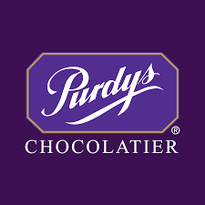
- The PAC is doing a Purdy’s Chocolate fundraiser. Orders DO NOT go through cash online rather you make the order through the Purdy’s link. The last day to order is November 25th. https://fundraising.purdys.com/1846814-112996
- Well done Cook! We raised $586 for the poppy donations.
- Hooray! Hooray! The Book Fair is here next week.

DID YOU KNOW?

Multiple studies have shown that avid readers demonstrate both superior literacy development and wide-ranging knowledge across subjects (Allington, 2012; Hiebert & Reutzel, 2010; Sullivan & Brown, 2013). Therefore, the more reading the better.

Upcoming Dates:
• November 29 – PAC Meeting
• December 21 – Term 1 Reports sent home
_____________________________________________________________________________________

