Cook Community
The Week Ahead: December 4 - 8, 2023
Monday | Breakfast Club
Tuesday | Breakfast Club
Wednesday | Breakfast Club  Student vs Staff Volleyball Game at Lunch
Thursday | Breakfast Club
Friday | Breakfast Club  TCO2 workshop for Div. 1-5

Important Information:

- We have several students who are coming to school sick. Please keep your child home if they are sick. From VCH:

Please keep your child home if they:
• Have a fever.
• Are too sick to take part in all normal school activities.
• Have a suspected or known communicable disease (i.e. strep throat, chicken pox, measles).
• Is vomiting or has diarrhea. It is recommended that students be symptom free at least 24 hours before returning to school.

- Another Scholastic Book Fair has wrapped up and this year was a huge success!
We sold over $7000 in products which means our library receives just over $3000 in books and $247.17 in cash reward. These books will be available for all our students soon!
A big thank you to the parents who volunteered their time to run the book fair. Thank you again for supporting Cook School's literacy program. Until next year...Happy Reading!
- Student vs. Staff Volleyball Game is scheduled for this Wednesday during lunch. Students who would like to watch the game should bring a food item to donate to the Food Bank.

Did You Know?
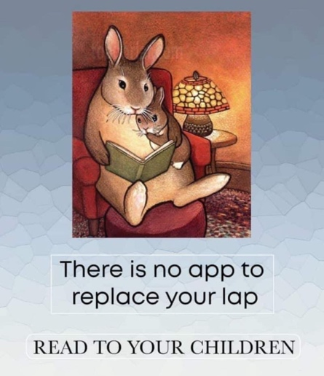

Upcoming Dates:
• December 13 – Gr. 6 Immunization
• December 18 – First Family Teams Get-Together
• December 21 – Term 1 Reports sent home
_____________________________________________________________________________________

~ Cook Highlights ~

Congratulations to our Book Fair Door Prize Winners:

