We invited 2 students from each class to join us for lunch for a little chat about our Cook’s Care Model.

As new administrators to the building as of January 2022, we wanted a chance to see what our learners think Cook cares for self, others and place both looks like and sounds like. Our data shows us that our learners know a lot of what it looks like to care for self, others and place. However, when we asked students to share what they think it may sound like, it appeared to be much more challenging.

Our next step is to share this data with our staff to see if there’s more we can do to help support our learners with how Cook Cougars say things to one another to show that we care about our self, each other, and this place.

From my scan, I hear staff sharing how many of our learners do not know how to self-regulate during unstructured times, particularly recess and lunch. I’d like to learn more about what this means to our colleagues. I think we need to get more explicit about the WHAT? so we can thoughtfully consider the HOW? / WHY? and NEXT STEPS.

What does COOK CARES…
look like… | sound like…
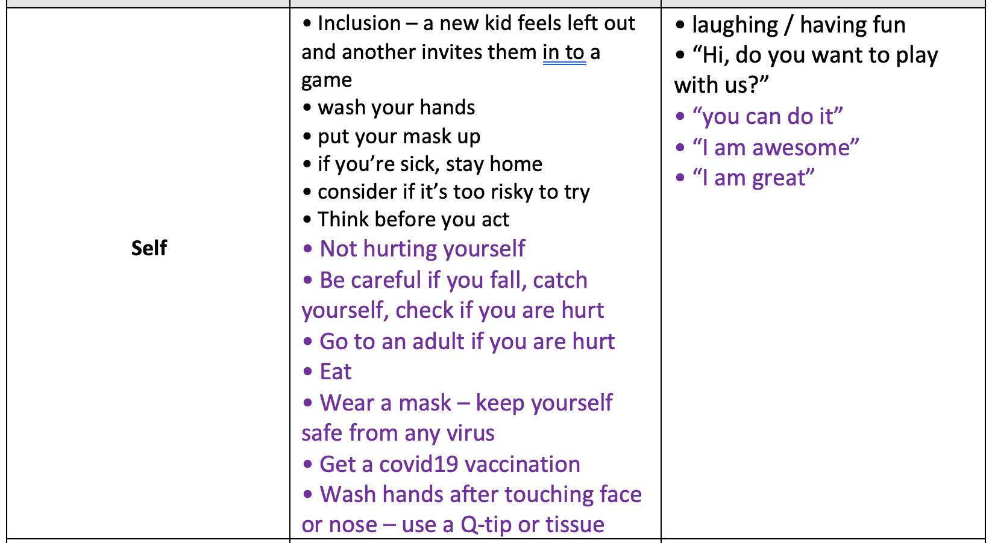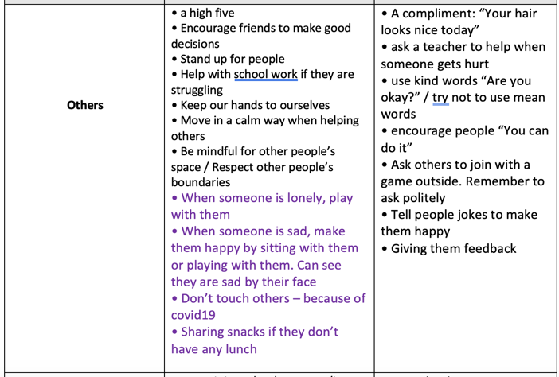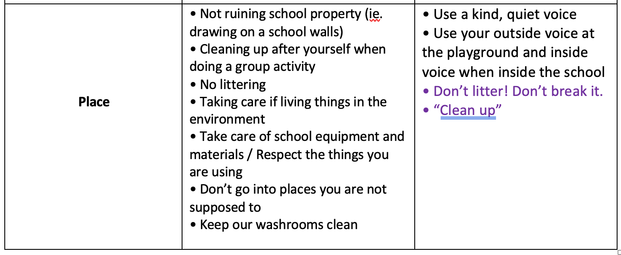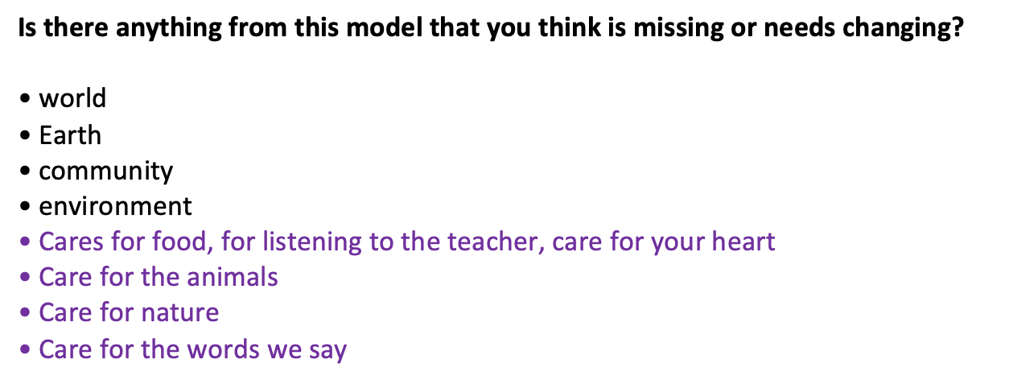

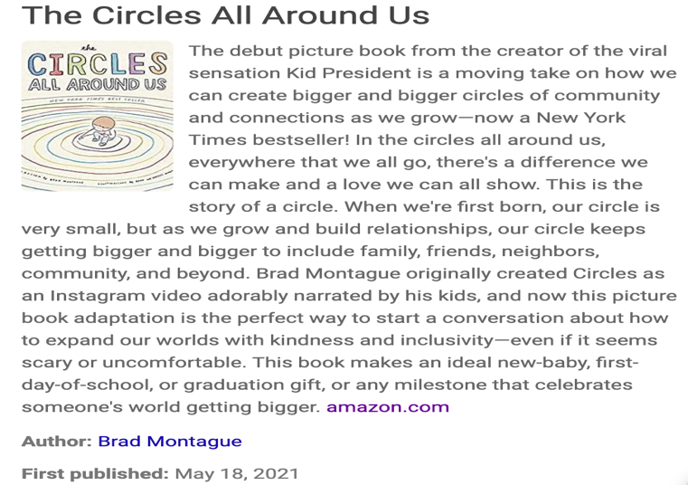
A picture book that we’re using as our 2022-2023 anchor text. This will be a school-wide focus in the first week of September and will guide us for all decision making so that we continue to align our decision-making around professional learning and school story goals. The book beautifully aligns with our Cook Cares model. Each staff member was given a copy in June as a gift to read over the summer.

We also asked students…

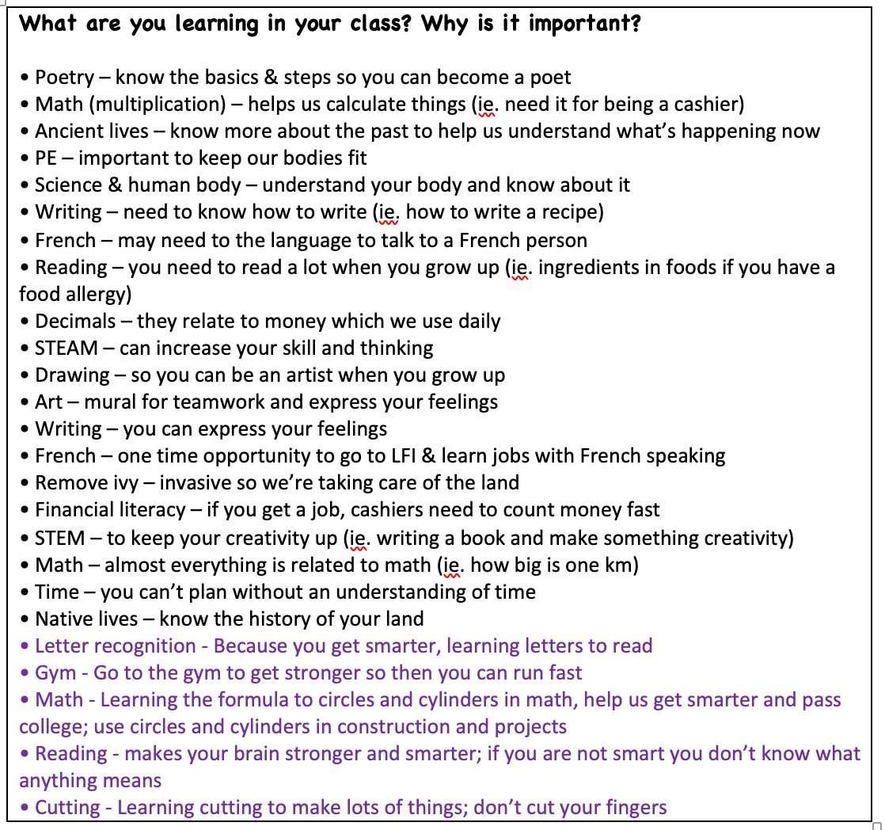
Next time, I would ask for an example to help go deeper with student responses.

Asking this question was important because:
- We want to see how our learners respond about their learning, and
- if they know why their learning is important

We think SEL is essential to all learning; it is the foundation. Yet, we also think it’s crucial to consider how our students are doing with their learning.

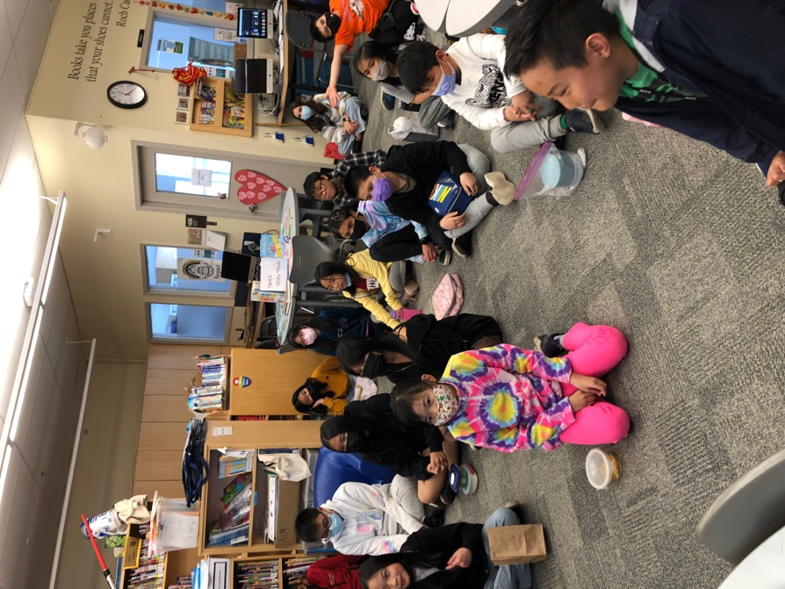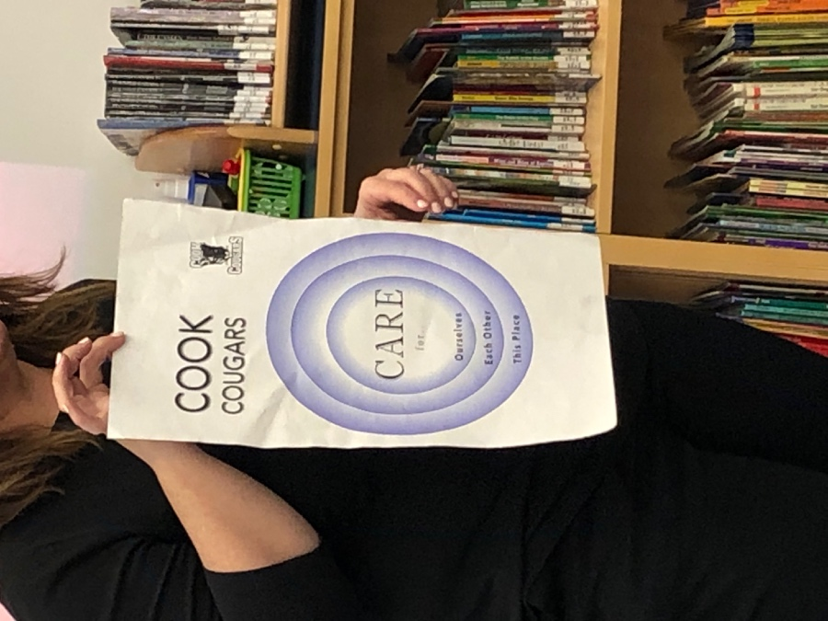

Stay tuned for what 2022-2023 has in store for us!

