As a school-wide activity, we all read Brad Montague’s book:
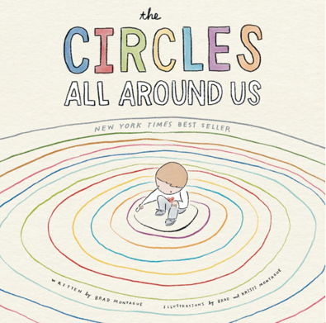

We decided that this picture book would be our anchor text for the remainder of the school year since it connects so well with our Cook Cares Model:
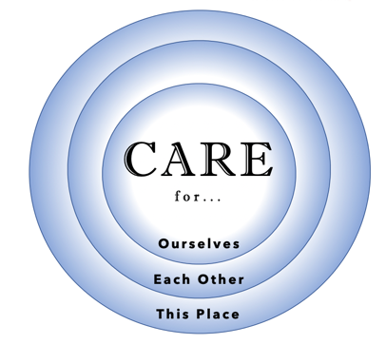

The story allowed us to ask our learners:

