Social-emotional learning (SEL) is always an important foundation for all learning. Cook School has worked for several years on building their understanding of the what, why, and how of fostering social-emotional learner to support all learners.

And now…we endeavour to look closer at reading. Previous data shows us that reading is an area that we need to further assess.

For example, UBC’s Middle-Years Development Instrument shares that our learners do not read for fun. We want to find ways to support reading and help our students see the JOY in it!
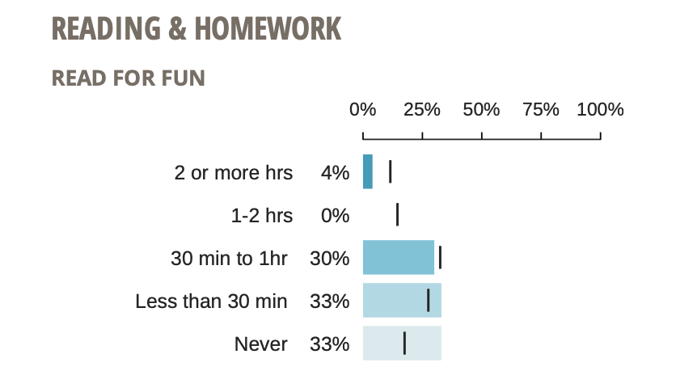

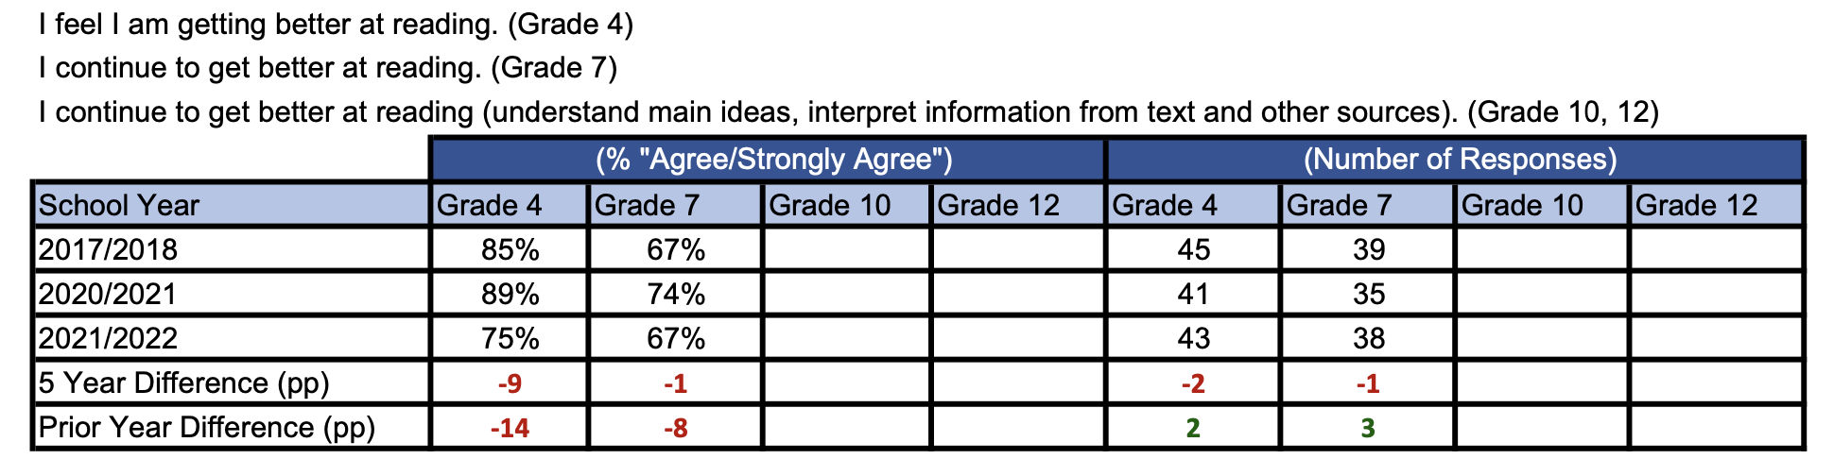
Further evidence, from the BC Ministry of Education’s Student Learning Survey, shows a decline in how our grade 4 and 7 students feel about themselves as readers.

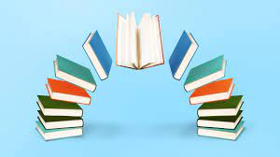
With this in mind, we begin a new journey that asks: What can our learners do, know, and understand when it comes to READING?

