Cook Community
The Week Ahead: November 27 – December 1, 2023
Monday | Breakfast Club
Tuesday | Breakfast Club
Wednesday | Breakfast Club  PAC Meeting at 3pm in the Library
Thursday | Breakfast Club
Friday | Breakfast Club

Important Information:

- The Christmas Fund is being offered again from November 15 - December 9. This year, you can go to Lansdowne Center (new location). Please see the link for more details:
https://www.rcrg.org/WhatWeDo/RCRGPrograms/richmond-christmas-fund/assistance

DID YOU KNOW?
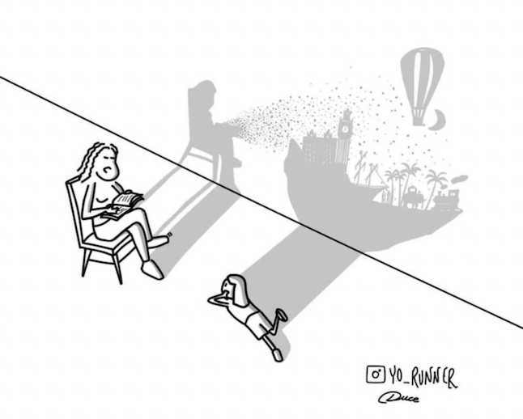
Readers make images in their minds.

Upcoming Dates:
• December 6 –Student vs Staff Volleyball Game at Lunch
• December 8 – TCO2 here from 9:00-10:00am in the Gym for Divisions 1-5
• December 13 – Gr. 6 Immunization
• December 18 – First Family Teams Get-Together
• December 21 – Term 1 Reports sent home
_____________________________________________________________________________________

~ Cook Highlights ~
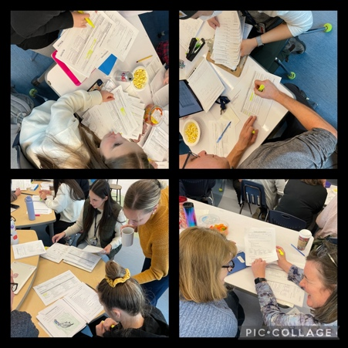
On November 20th, our staff participated in Professional Learning. We had the opportunity to work alongside our Teacher-Consultant, Briana Adams, to assess how are learners are doing with their reading.

