Cook Community
The Week Ahead: February 19 - 23, 2024
Monday | NO SCHOOL – Family Day
Tuesday | Breakfast Club
Wednesday | Breakfast Club  Gr. 7 Boys Basketball @ Cook vs. Garden City
Thursday | Breakfast Club  PAC Lunch: Elephant’s Kitchen
Friday | Breakfast Club  SPIRIT DAY: Dress up as your favorite villain  Gr. 7 Girls Basketball @ Currie

Important Information:

- There is NO SCHOOL on Monday, February 19th as it is Family Day.

- As of Tuesday, February 20th, the meadow at the front of our school will be closed for a play space for our youngest learners as construction for our new addition will begin. An email about this was shared earlier this week to all Cook families.

- On Friday, February 23rd, we are excited to see both students and staff come dressed up as their favorite villain from a book. You may consider ideas such as: Dracula, Captain Hook, Ursula the Sea Witch, The Grinch, and Cruella de Vil.

DID YOU KNOW?

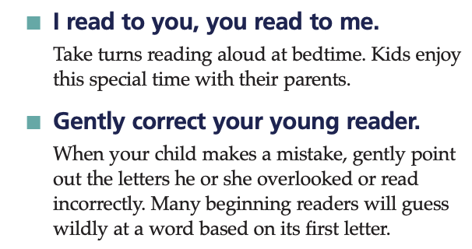

Upcoming Dates:
February 26 – Gr. 7 Girls Basketball @ Cook vs. Anderson
February 27 – Gr. 7 Girls Basketball @ Cook vs. Currie
February 28 – Anti-Bullying Day (Pink Shirt Day)

Wishing you a wonderful FAMILY DAY! If you are looking for some ideas of what to do as a family,
consider looking at the City of Richmond events.

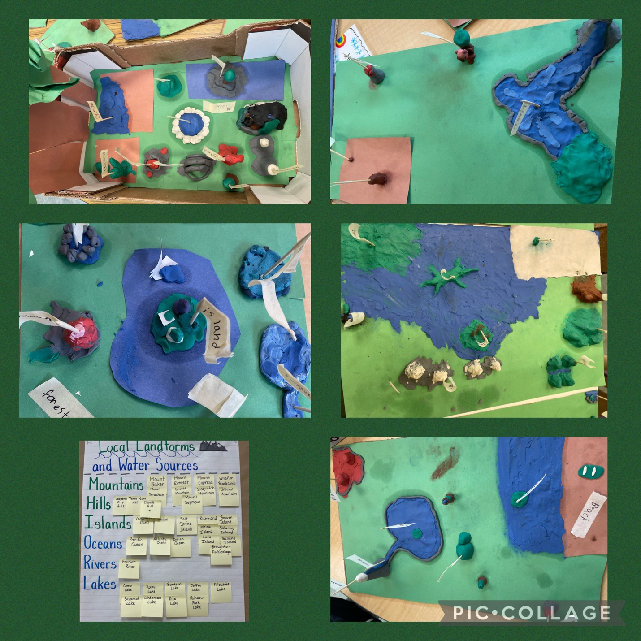

Landforms by Ms. Jackson’s Grade 2/3 class

