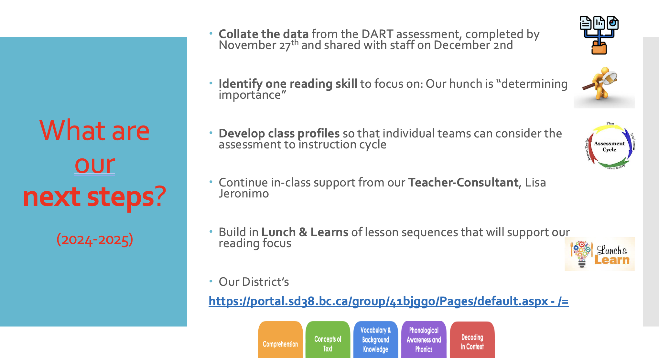

• CEF Funds – our grade 1 and ½ team is working with Faye Brownlie.

